**ELEC-E7120 Wireless Systems**

**Homework for Unit 2**

Name: Xingji Chen

Student Number: 101659554

Problem 2.1 (1 point). *Link Budget in 5G FR1 (Low and mid bands)*

According to the scenario below:

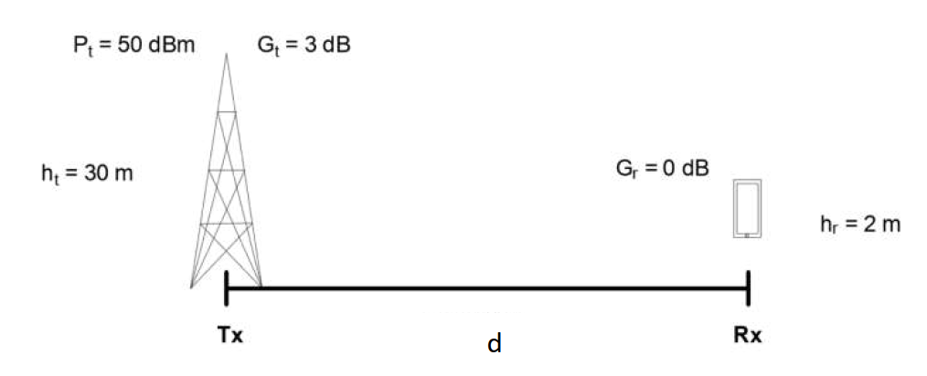

1. Calculate the propagation loss (in dB) using the free space path loss model when working in the 5G frequency band 700 MHz when the distance (d) is 500 meters.
2. Calculate the propagation loss (in dB) using the free space path loss model when working in the 5G frequency band of 3.5 GHz when the distance (d) is 500 meters.
3. Assuming that the sensitivity of the receiver is 80 dBm, what are the respective coverage ranges of a radio system that use both frequency bands (i.e., 700 MHz and 3.5 GHz)? For this computation, only use the free space path loss (i.e., shadowing and fast fading margins are neglected)
4. Compare results in (c) and suggests considerations of a mobile operator when deploying base stations in both frequency bands in their existing 4G cell sites.
5. The free space path loss (FSPL) can be calculated using the following formula:





When , 



The free space path loss is 80.32 dB.

1. When , 



The free space path loss is 94.30 dB.

1. The sensitivity of the receiver is -80 dBm, , so the maximum free space path loss



When , let



Hence



When 

let



Hence



The respective coverage ranges of a radio system that use both frequency bands 700 MHz and 3.5 GHz are 152.34 km and 30.47 km.

1. If base stations use both the 700MHz and 3.5GHz frequency bands with a coverage range of 152.34 kilometers and 30.47 kilometers, respectively, this indicates a significant difference in coverage between the two frequency bands.

The 700MHz frequency band provides a larger coverage range, reaching 152.34 kilometers. This makes it suitable for providing broad coverage, especially in rural and less populated areas.

The coverage range of the 3.5GHz frequency band is relatively short, at 30.47 kilometers, making it more suitable for urban and densely populated areas, where there is a higher demand for high-capacity data services. It can cover user dense areas.

Problem 2.2 (1.5 points). *Path loss in a two-ray model with flat earth*

Assume a two-ray model, like the one shown in the figure below, where the height of the transmit antenna (*ht*) is 15 meters, the height of the mobile station antenna (*hr*) is 2 meters, and the frequency of the radio frequency carrier is 900 MHz. Consider that isotropic antennas are deployed in both transmitter and receiver (i.e., antenna gain is 0 dBi).

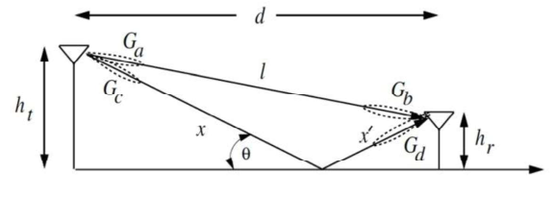

1. Using the exact formula below of the path loss attenuation for the **two-ray model**, which is valid before and after the so-called breakpoint distance, compute the attenuation (dB) that the radio signal experience in reception when d = 80, 89.9, 90.1, and 100 meters. What happens when the receiver is precisely at a horizontal distance of 90 meters from the transmitter? Why? Please, justify you answer in a simple but clear way.



1. Let us now assume that reflected signal on the ground becomes negligible due to absorption, and that the **line-of-sight (free-space)** propagation between transmitter and receiver dominates. What is the attenuation (dB) that the received signal observes in this new situation at the same distances (i.e., d = 80, 90 and 100 meters)?
2. **Compare the results in both cases**. How does attenuation change with distance in both cases? Does it show a monotonous or non-monotonous behavior? Is it always stronger the received signal power in presence of a second ray reflected from ground (i.e., a two-ray model) in a) when compared to the single-ray case in b)? Why/why not? Justify your observations in a simple but clear way.
3. The exact formula below of the path loss attenuation for the two-ray model is



The path loss attenuation (in dB) can be calculated as



Hence



Given that the frequency (*f*) is 900 MHz, the wavelength (*λ*) can be calculated as



When *d* = 80 m



When *d* = 89.9 m



When *d* = 90.1 m



When *d* = 100 m



At 90 meters, the receiver is located at the 'breakpoint distance'. The two-ray model has a turning point where the calculation of path loss is different before and after this distance.

Before the breakpoint distance, path loss rapidly increases with distance, mainly due to the direct path from the transmitter to the receiver.

After the breakpoint distance, the path loss still increases with the distance, but the growth rate is slower because the ground reflection path begins to dominate and does not decrease rapidly like the direct path.

Therefore, when the receiver is located at a horizontal distance of exactly 90 meters, the path loss is relatively high at the breakpoint distance in the two-ray model, which is about 107.7 dB.

1. The free space path loss (FSPL) can be calculated using the following formula:



When , 



When 



When 



1. In the two-ray model, the path loss behavior is non-monotonic because of the interaction between straight and reflected rays. There exists a breakpoint distance (at about 90 meters) at which the path loss peaks. After that distance it continues to increase, but at a slower rate. At 90 meters, the reflected and direct signals are opposite in phase, so the path loss is the largest.

In line-of-sight (free-space), the path loss behavior is monotonic and steadily increases with distance. This is due to the fact that only free-space path loss is considered, without the complex interactions between multiple rays.

In two-ray model, initially the signal power received at shorter distances is weaker because there is interference between the straight and reflected rays, resulting in higher path loss. However, as the distance increases, the reflected rays become weaker and the received signal power increases, leading to a lower path loss compared to the single ray model free-space model.

Problem 2.3 (1.5 points). *Free space propagation in space & terrestrial point-to-point links*

* 1. **Deep space missions**. ESA space probe transmitter is communicating with the Earth station. When the planet Saturn is 1.2×109 km, the satellite transmit power is 57 dBm using a carrier frequency of 28 GHz. The minimum power of the received signal must be -105 dBm at the parabolic dish antenna on Earth for a proper detection of the transmitted information. What is the antenna gain of the satellite transmitter, assuming that the receiver’s antenna gain is 13 dB larger than the one of the transmitter antenna?

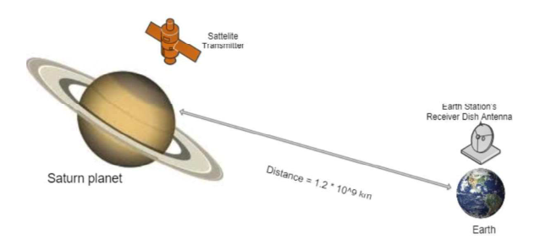

* 1. **Passive repeater for hilly terrain**. To provide the Internet service in a rural location, there is an option to Wi-Fi service (unprotected with no security key) from the town, which is located 10 km away from the summer cottage on the other side of the mountain as shown in the figure below. This town has several unprotected Wi-Fi servers providing internet service. To forward the Wi-Fi signals from the town to the summer cottage, three microwave dish antennas operating at 2.45 GHz are arranged in the following configuration: Dish A and Dish B located on the mountaintop work as a passive repeater that retransmits the signals towards the Dish C located on the rooftop of a summer cottage.

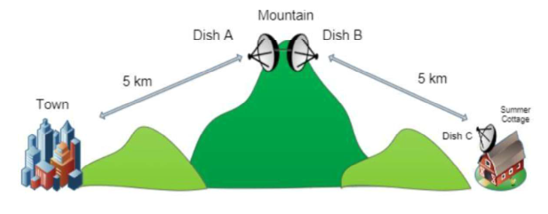

The transmission power of Wi-Fi servers in town is assumed to be 30 dBm with an antenna gain of 5 dBi. To enable optimal wireless internet at the summer cottage, the sensitivity of the receiver (i.e., the minimum received signal level for a proper operation) must be -95 dBm. Cables are assumed to be perfectly matched in impedance, introducing no power losses. What is the minimum gain for all three microwave dish antennas in dBi in order to provide proper Internet service in the summer cottage?

1. In satellite transmission, use the Friis transmission equation, which relates the transmit power, receive power, and antenna gains as follows



Where







Hence



Then



So, the antenna gain of the satellite transmitter is approximately 64 dB.

1. Friis transmission equation is



In the first line (town to dish A)



For dish B



In the second line (dish B to summer cottage)



Where







Hence



So



So, the minimum gain for all three microwave dish antennas (Dish A, Dish B, and Dish C) in dBi to provide proper Internet service in the summer cottage is approximately 32.8 dBi.